**TAXATION AND SUPERANNUATION**

Visit <http://www.ato.gov.au> and look up the section "Individual".

1. Outline five reasons why you need a tax file number.
2. Describe how you get a tax file number.

**Key definitions**

Define taxation; compulsory payments by firms and individuals to the Federal Government, for which no direct benefit is gained.

Indirect taxation, Goods and Services Tax (GST) in Australia is a value added tax of 10% on most goods and services transactions. GST is levied on most transactions in the production process, but is refunded to all parties in the chain of production other than the final consumer.

In Australia direct taxes (income and company taxes) comprise approximately 70% of Federal Government revenue. The ATO is expecting a tax pie of around $387.7 billion. So – where does it all go?

Each year in May the Australian Government releases its budget for the upcoming financial year. Part of that release includes two pie charts which summarise Australian Government revenues and expenses for 2013‑14 on an accrual basis. These charts are below.

**This is where revenue comes from:**

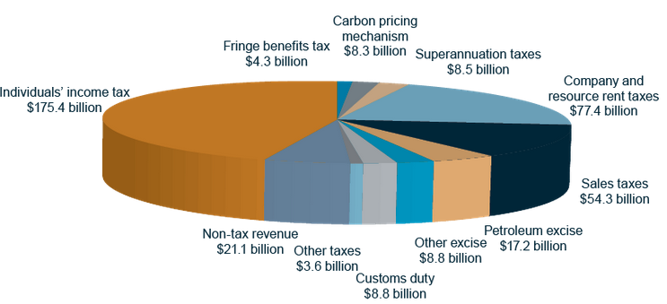

*Source: The Commonwealth of Australia*

**Here, according to government estimates, is where the revenue that is collected will be spent:**

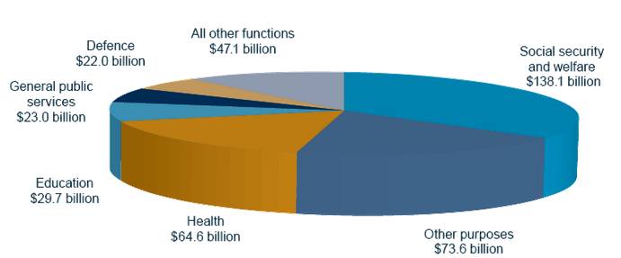

*Source: The Commonwealth of Australia*

The government uses the Budget to reallocate resources to achieve sustainable economic growth over the medium term and to redistribute income to maintain high standards of living for all residents in our community.

|  |
| --- |
| Economic Cycle  Real  GDP  Time |

The government changes revenue and expenditure to smooth the cycle. Describe this process.

|  |
| --- |
|  |
|  |
|  |
|  |
|  |
|  |
|  |

The Government uses a progressive tax system to redistribute income from high income earners to the disadvantaged and low income earners to achieve high standards of living. Some economists refer to this process as transfer payments.

Below are the current tax schedules from the ATO web site.

Tax rates 2014-15

|  |  |
| --- | --- |
| **The following rates for 2014-15 apply from 1 July 2014.** | |
| **Taxable income** | **Tax on this income** |
| 0 – $18,200 | Nil |
| $18,201 – $37,000 | 19c for each $1 over $18,200 |
| $37,001 – $80,000 | $3,572 plus 32.5c for each $1 over $37,000 |
| $80,001 – $180,000 | $17,547 plus 37c for each $1 over $80,000 |
| $180,001 and over | $54,547 plus 45c for each $1 over $180,000 |

Calculate the tax payable for the average worker in Australia on a total income of $60,000

|  |
| --- |
|  |

Approximately 1% of the labourforce earn taxable income over $100,000. Calculate the tax payable on $100,000

|  |
| --- |
|  |

Calculate the total tax payable for individuals earning $200,000

|  |
| --- |
|  |

Now plot this information on a graph

|  |
| --- |
| Tax payable  income  levels 0 60,000 100,000 200,000 |

What do you notice?

|  |
| --- |
|  |
|  |
|  |
|  |

Complete the table below

|  |  |  |
| --- | --- | --- |
| Income level | Total tax payable | Average tax rate |
|  |  |  |
|  |  |  |
|  |  |  |

What do you notice?

|  |
| --- |
|  |
|  |
|  |
|  |

|  |  |
| --- | --- |
| taxation   * reasons for taxes * types of taxes | * describe the range of services funded by taxation * explain the relationship between taxation, income and government-funded services |

Tax terms.

Define each of the following.

|  |  |
| --- | --- |
| Taxation |  |
|  |
|  |
| Direct tax |  |
|  |
|  |
| Indirect tax |  |
|  |
|  |
| Progressive tax |  |
|  |
|  |
| Regressive tax |  |
|  |
|  |
| Proportional tax |  |
|  |
|  |
| Customs or excise duty |  |
|  |
|  |
| Tax-free threshold |  |
|  |

The Federal Government has a social policy to reduce the level of inequality in Australia. The government uses a progressive tax system and transfer payments (welfare) to reduce the gap between the rich and poor and achieve an acceptable standard of living for all Australians.

The system of progressive taxation on personal income means that the more a person earns the more tax they pay as a percentage of their gross income.

Gross income is total income.

Disposable income is gross income minus total tax payable.

1. The basic wage in Australia is $570 per week. Calculate the total tax payable and the average tax rate on the basic wage.

|  |  |
| --- | --- |
| Total tax payable | Average tax rate |
|  |  |

4. Explain how the tax schedules from the ATO web site illustrates the progressive tax system.

|  |
| --- |
|  |
|  |
|  |
|  |

5. Suggest reasons for a debt levy on higher income levels.

|  |
| --- |
|  |
|  |
|  |
|  |

Use the pie charts on the booklet pages and your textbook to answer the following questions.

**Revenue.**

1. What proportion of total Revenue is collected from individual income tax?

|  |
| --- |
|  |

1. What proportion is collected from Company tax?

|  |
| --- |
|  |

1. What is *fringe benefits* tax? (give examples)

|  |
| --- |
|  |
|  |
|  |
|  |
|  |

1. What is the sales tax and what happens to this revenue?

|  |
| --- |
|  |
|  |
|  |
|  |

**Outlays**

1. Name the area of greatest spending in the current Budget (what proportion of total spending is it)?

|  |
| --- |
|  |
|  |

1. After looking at Government Revenue and Spending, describe the main role of the Government.

|  |
| --- |
|  |
|  |
|  |
|  |
|  |
|  |
|  |